Case 14-MEX-Mezcala Crouching Figures

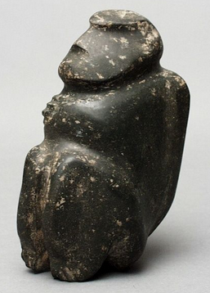

<https://www.pinterest.com/pin/352336370826670776/>

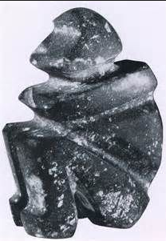

[https://www.google.com/search?as_st=y&tbm=isch&as_q=&as_epq=Mezcala+mask&as_oq=&as_eq=&imgsz=&imgar=&imgc=&imgcolor=&imgtype=&cr=&as_sitesearch=&safe=images&as_filetype=&as_rights=#imgrc=lYMarqY6aGxAeM](https://www.google.com/search?as_st=y&tbm=isch&as_q=&as_epq=Mezcala+mask&as_oq=&as_eq=&imgsz=&imgar=&imgc=&imgcolor=&imgtype=&cr=&as_sitesearch=&safe=images&as_filetype=&as_rights=" \l "imgrc=lYMarqY6aGxAeM):

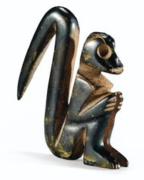

https://s-media-cache-ak0.pinimg.com/236x/80/e3/f0/80e3f034e9379ec00b67e4df415d5aee.jpg

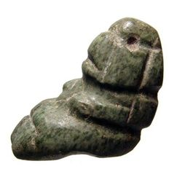

[https://www.google.com/search?as_st=y&tbm=isch&as_q=&as_epq=Mezcala+mask&as_oq=&as_eq=&imgsz=&imgar=&imgc=&imgcolor=&imgtype=&cr=&as_sitesearch=&safe=images&as_filetype=&as_rights=#imgrc=quxNLCy4nxNVaM](https://www.google.com/search?as_st=y&tbm=isch&as_q=&as_epq=Mezcala+mask&as_oq=&as_eq=&imgsz=&imgar=&imgc=&imgcolor=&imgtype=&cr=&as_sitesearch=&safe=images&as_filetype=&as_rights=" \l "imgrc=quxNLCy4nxNVaM):

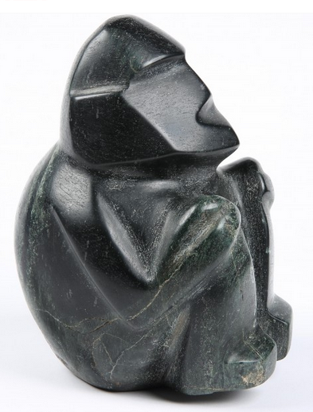

the artist Sir John Lavery, R.A. (1856-1941) who occupied Every Object Tells a Story, a public exhibition on view from 4 May to 5 July 2017 at 5 Cromwell Place, London. from 1899 until his death

after ttps://www.artweek.com/events/united-kingdom/art-exhibition/london/every-object-tells-story#

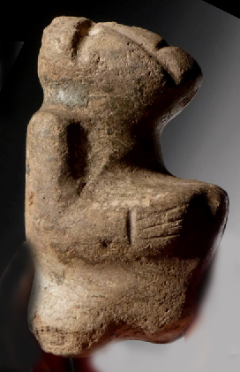

Mezcala crouching stone figure 700 B.C. - 650 A.D., 4.5" tall x 2.5" high x 2.4" wide. Provenance: PALEO DIRECT  is one of the world's largest and most diversified professional suppliers. Orlando, FL  Since 1986, AP: 9 After https://www.paleodirect.com/pc081-pre-columbian-mezcala-stone-sculpture-of-kneeling-figure-with-evidence-of-copper-neck-ring-from-guerrero/#PhotoSwipe1515262047836